SYNOPSIS OF

***The Secret Power - A Anonymous Society***

Submitted By

**Juned**

for the award of the degree

of

**Bachelor of Computer Application**



**Hindu Institute of Management**

Hindu Institute of Management, Near Railway Station Road,

Rohtak Road, Sonepat – 131001 Delhi - NCR

Mobile :- 08901440704 , 08901440705

**The Secret Power**

**Overview**

A strong advocate of Satya (Truth) and Ahinsa (non-violence), Gandhi showed the power of love and non-violence in combating injustice and oppression. Mahatma is the title given to this inspiring personality who led the masses with his optimism, courage, his principles, and practice

Mahatma Gandhi ji said "Freedom is not worth having if it does not include the freedom to make mistakes". And he gave us the sweetest gift which was freedom of thought, but somewhere today we are losing it, we are losing it because, Some people who have money, some people who have power. Those people are suppressing people with their power and money. That's why now there is a need for a platform where we can all share our thoughts, where no one is big or no one is small. Those people have gone wrong with them, those people who want to tell their truth, our community will welcome everyone. Everywhere, Every time.

**Objective**

1. **Freedom of thoughts:** Freedom of the thoughts is the biggest power in the world, Doesn't matter who you are?, where are you?
2. **Throw out lies**: Sometimes we are suppressed by the people who have more power, Who have more money. But our community will welcome everyone. Everywhere, Every time they share their thoughts without any fear.

**Project Description**

One of the most disadvantages of the similar apps is limited users can join similar groups. But the Secret Power will be quite different. We don't need to create groups as here all Matters will be identified by the Hashtags.

The biggest specification of the “The Secret” will be? Yes of course! Secret. Now here you are completely safe. We will now let them know about your real name and your real identity. Any user can login here by their phone number. No one will be able to see about your identity.

You can post your thoughts on any people, Any politician, Any place, Any Country, Or any organisation.

**Privacy**

It is not just the secret chats of Secret Power that guarantee greater security in the app, since all the content uploaded by the user only will be deleted and uploaded by the user only who has uploaded the content. We will not have any traceable identity where a user can be traced, there will not be any name and profile picture. The thing which will be named as “Anonymous” & profile picture will be the avatars which do not have any real existence.

**Project Category**

Definitely the project falls under the category of the information Technology, All the there will be no more software requirement and Specific hardware will be required to use “The Secret”. But it also will fall in the category of humanity. When we will give them the power of sharing thoughts

**Structure of the program**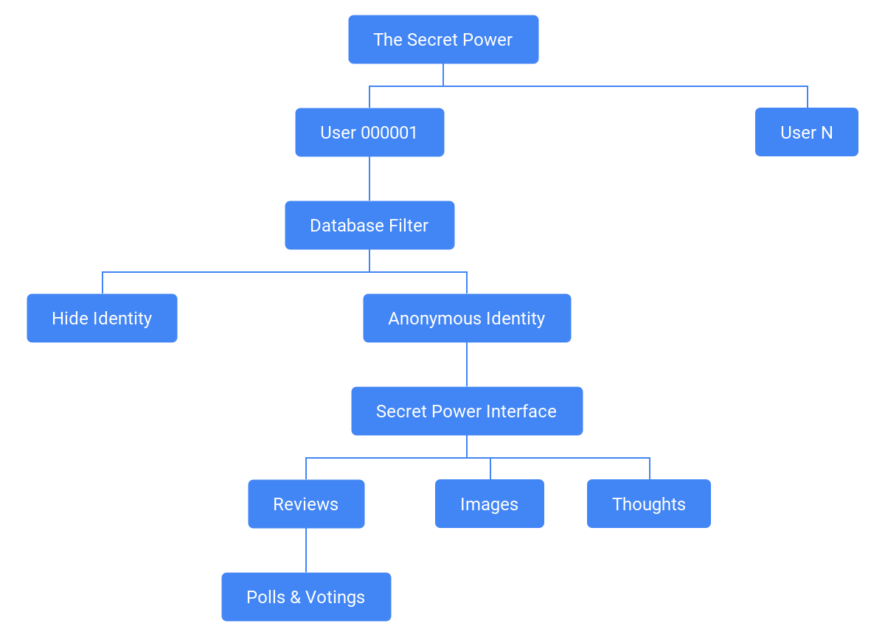

**Requirements**

We know that it is possible to use WhatsApp in your browser, but the way it is done is very limited and far from ideal. Meanwhile, you can Use Secret Power on Smartphone, Tablet, and even most browsers on your computer.

The best thing is that none of this requires a lot of the user, just download the corresponding app for each platform, log in with your account and start enjoying the service. Of course, this makes it much more secure and stable, so it’s worth testing.

Any Browser Chrome, Mozilla, FIrefox, Internet Explorer etc.

Any Hardware which supports Internet & Browser.

**Languages**

HTML, CSS, JAVASCRIPT, JQUERY, PHP, PYTHON, DJANGO, JAVA, BOOTSTRAP, FRAMEWORKS,

**Future scope of the Project**

Let's wait for some time we all person want to express what we exactly thought but we don’t have a medium or environment to express our self so that we are building a platform and addict them to express their secret and thoughts now so that they feel better after some years and have fun everyone every future kids will come in our website and said their inner secret without their identity loss.

**Conclusion**

We work for the community & this is all our conclusion.